
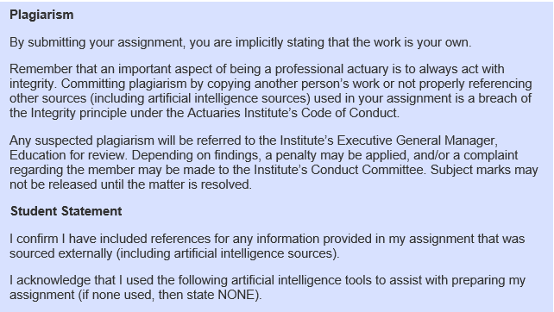
Tool | Purpose
<name of tool> | <brief description of purpose>
Add rows as required

